Prayer for our USA/Canada Missionaries

Joe and Amy Hall-USA
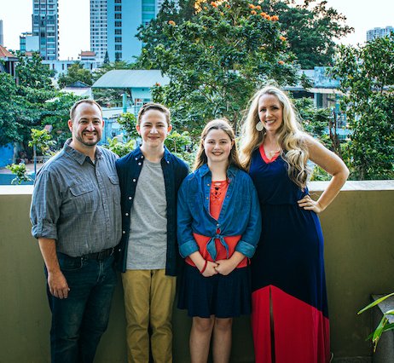
USA/Canada Region

Rhesa and Roberto Rodriguez-El Paso, TX
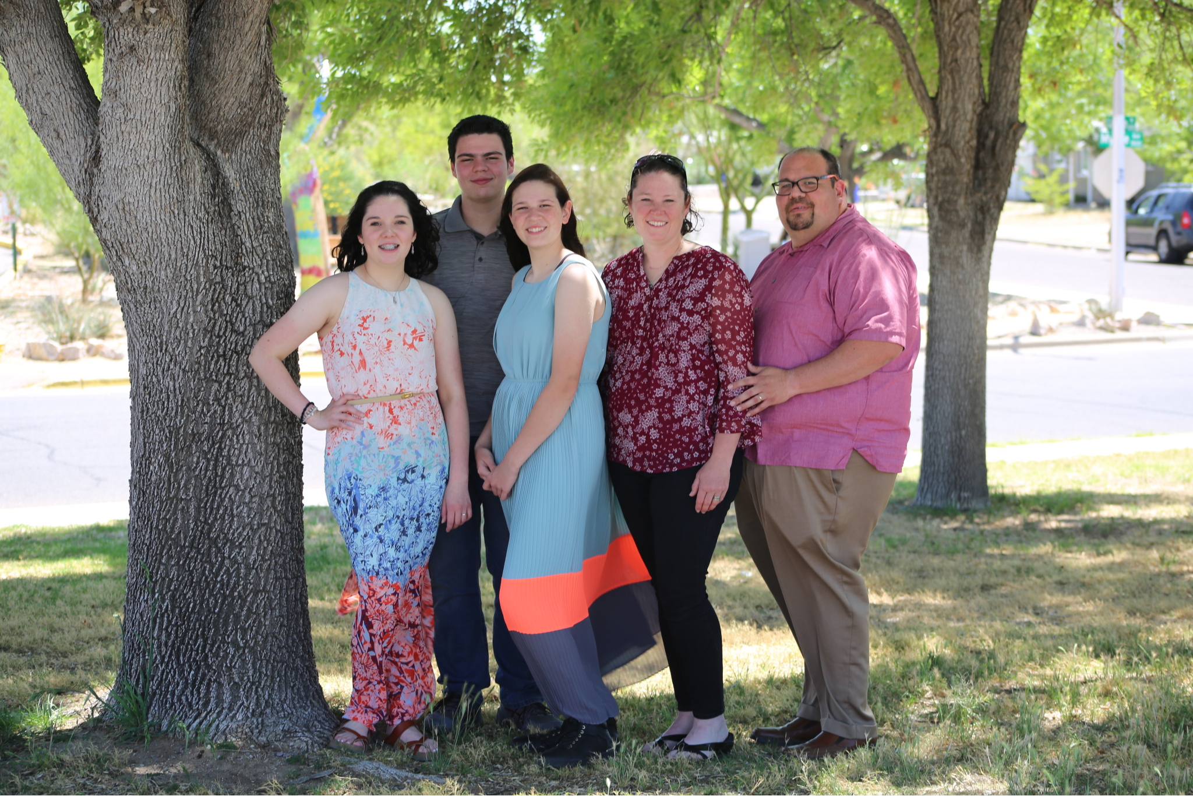
USA/Canada Region

Sam and Kristi Senica-USA Oklahoma City
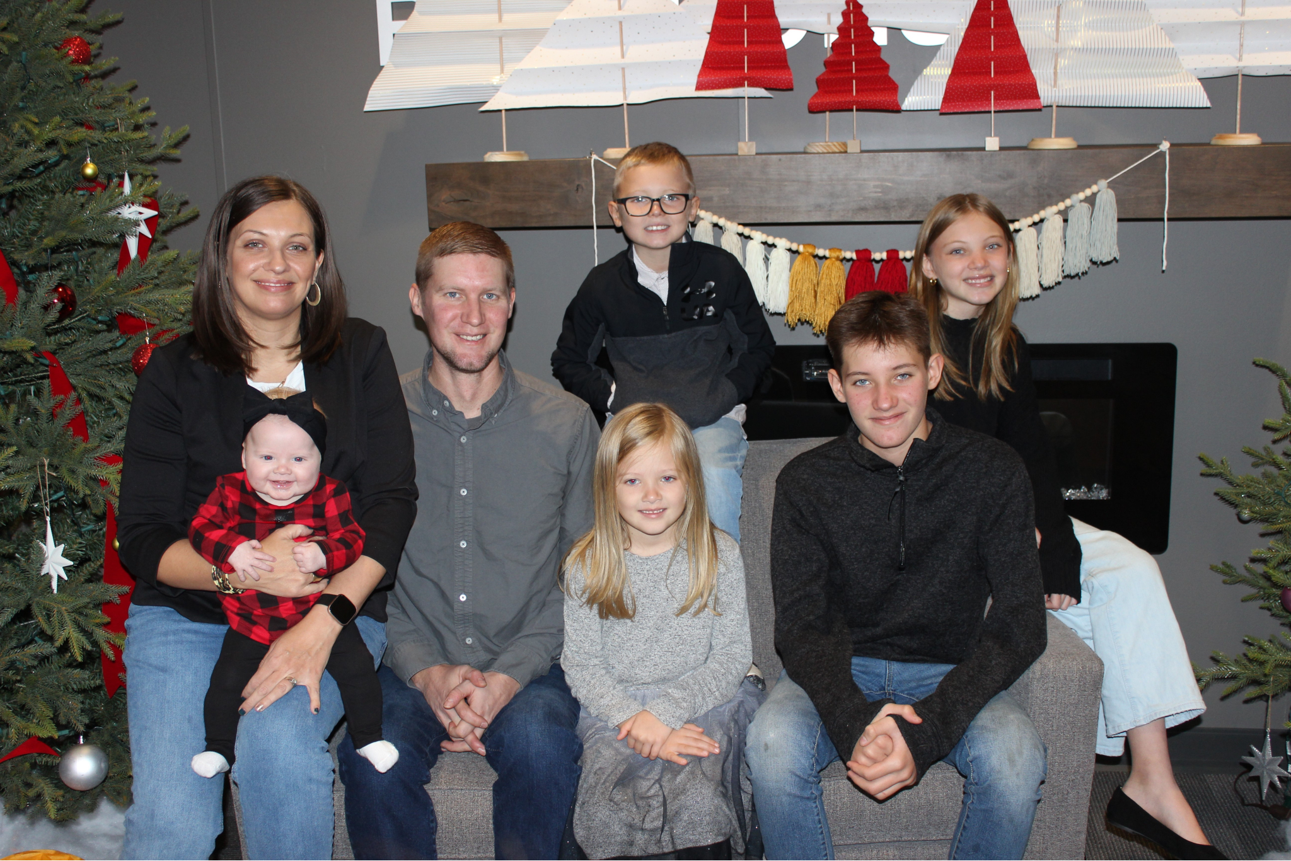
USA/ Canada Region

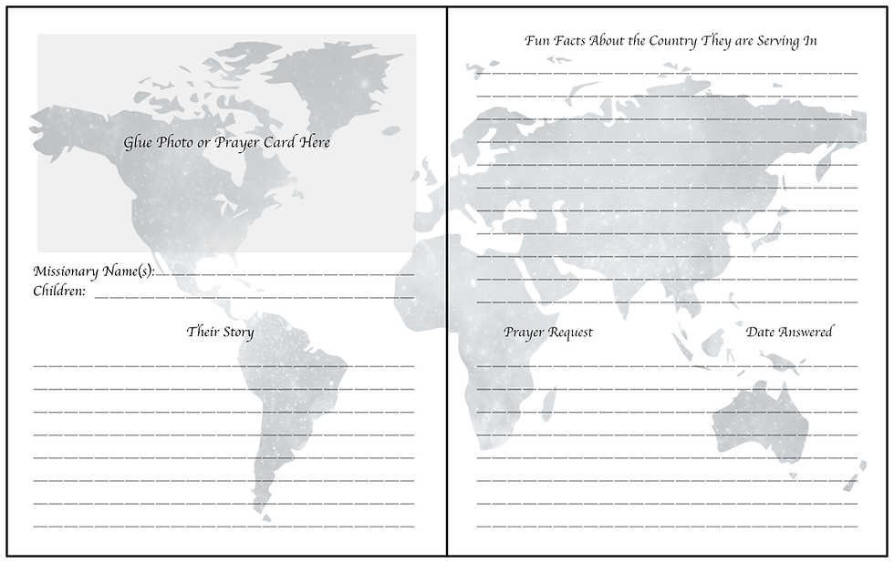

Pray for our Global Missionaries:

Brian Helstrom-USA
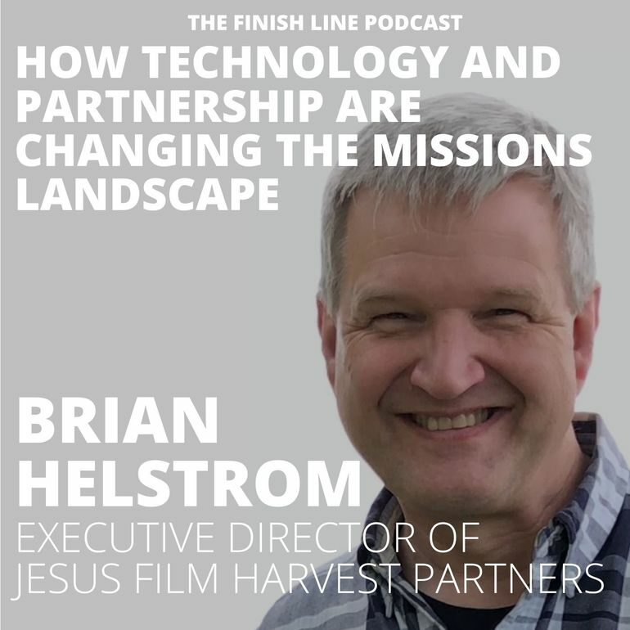
USA/Canada Region

Brian Utter-USA
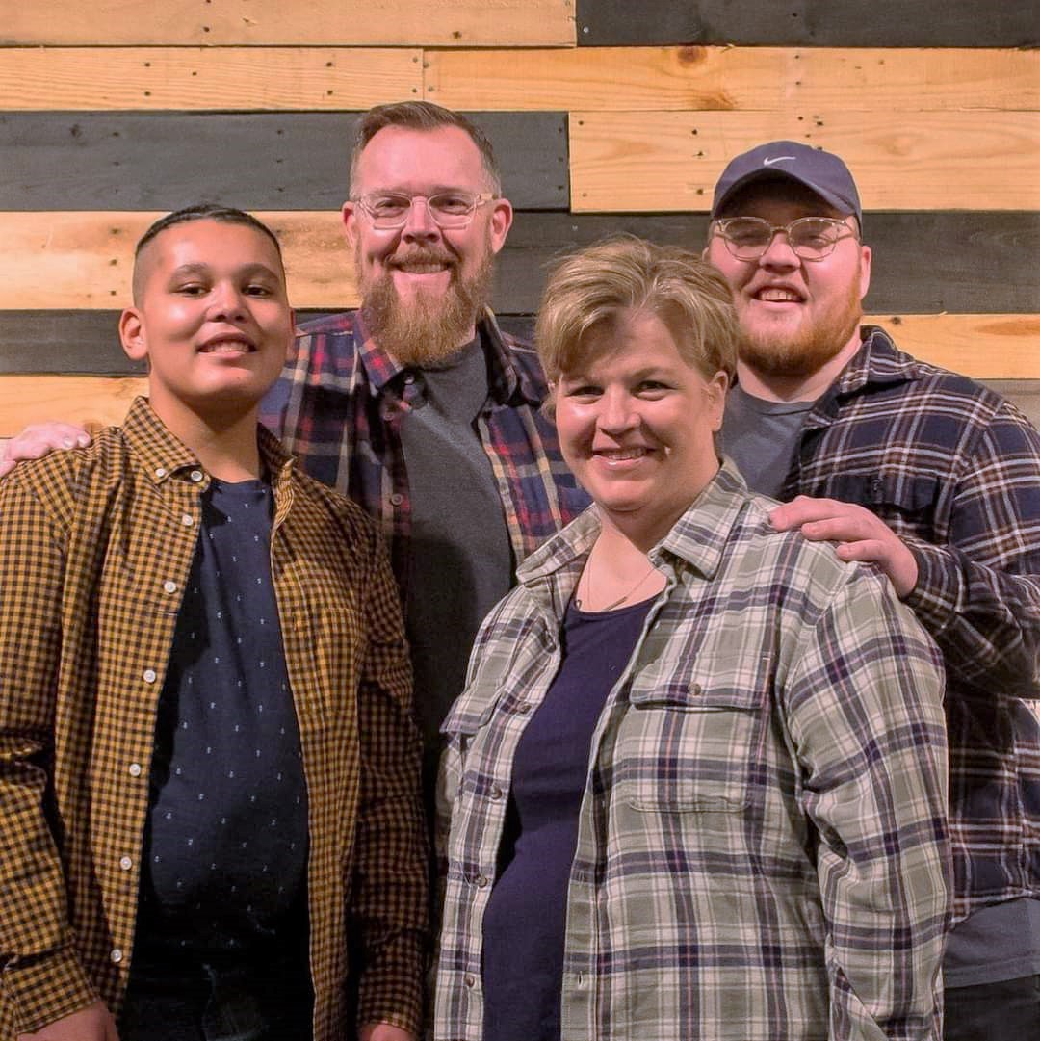
USA/Canada Region

Daniel Herrera-USA
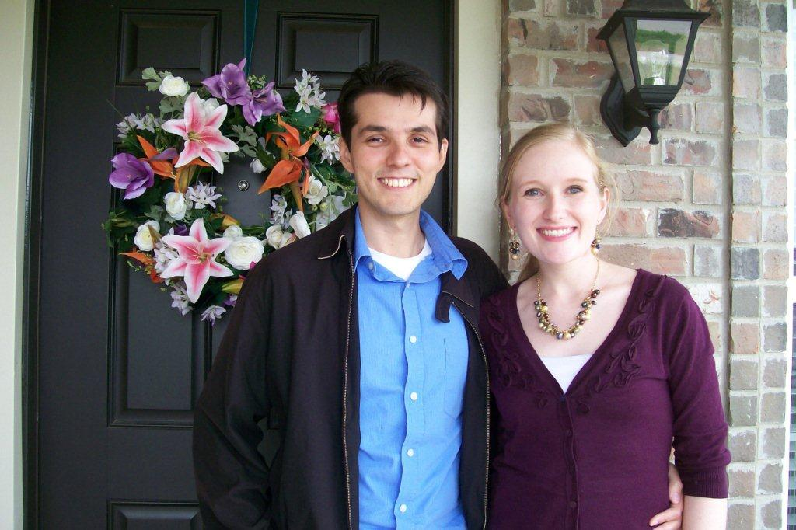
USA/Canada Region

Grant Zweigle-Ontario, Canada
USA/Canada Region
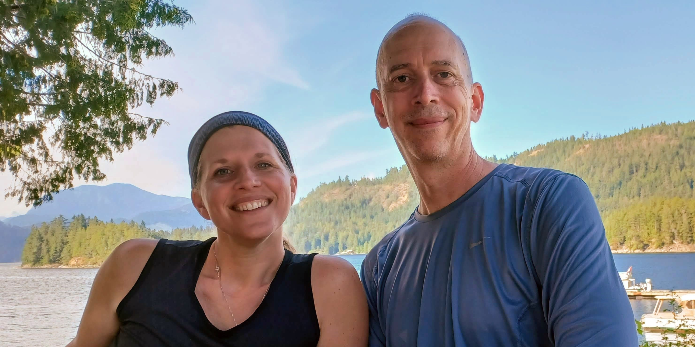

Joshua Williams-Idaho USA
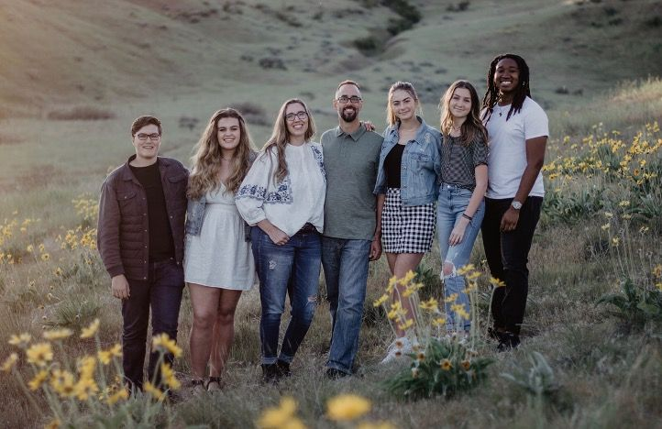
USA/Canada Region

Stan Reeder- Canada
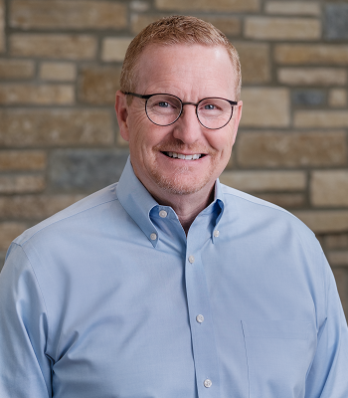
USA/Canada Region Director

The USA Canada Region has 78 Districts, 5,100 churches and 600,000 members! Pray for renewed vision and energy in the USA/Canada region. Pray for revival!

